Computer Language Coding Concepts

Object Reference Class Assignment in a Diagram
The principle of object reference class assignment is explained in the article Object Reference Class Assignment. This article demonstrates the expression of it in a diagram.

An assignment is a call to an assignment command, but the expression of an assignment call is given a more basic notation than a command call. An object reference object assignment looks as follows in a diagram:

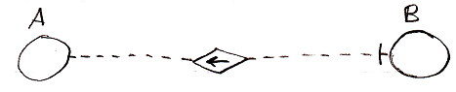

The fact, that it is a dashed line, expresses, that it is a class assignment. The fact that the diamond contains an arrow pointing to the reference target, makes it an object reference assignment. Altogether it is an object reference class assignment. The access mark indicates the direction of the assignment. Object reference A is assigned as the class target of object reference B.

About the notation of object reference assignment in general and diagrams of the effect of an object reference assignment, see the article Object Reference Assignment in a Diagram.

The notation of an assignment letting a command’s definition point to a reference to a command is the same, but then between command symbols:

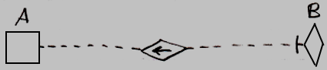

In the example above, symbol A is a non-executing (square) command symbol, and symbol B is a diamond, which stands for a call, but both symbol A and B cold have been either squares or diamonds.

See also: Object Reference Class Assignment, Object Reference Assignment in a Diagram, Assignment in a Diagram

Author & Copyright: Jan-Joost van Zon Date: July 25, 2008 – July 25, 2008 Location: Oosterhout, The Netherlands Status: Finished

